# Mathematical Methods in Engineering and Applied Science Problem Set 10.

1. Solve the initial value problem for the advection equation

$$u_{t}+\left(1-t\right)u_{x}=0, t>0,x∈R$$

$$u\left(x,0\right)=\frac{1}{1+x^{2}}$$

Plot the characteristic curves as well as the solution u(x,t) at several different times.

$$\frac{dt}{ds}=1, \frac{dx}{ds}=1-t, \frac{du}{ds}=0$$

$$dt=ds, x=t-\frac{t^{2}}{2}+c$$

For initial: $x=p, t=0, u\left(p,0\right)=\frac{1}{1+p^{2}}:$

$$x=t-\frac{t^{2}}{2}+p, u=\frac{1}{1+p^{2}}=\frac{1}{1+{\left(x-t+\frac{t^{2}}{2}\right)}^{2}}$$

Characteristics:   
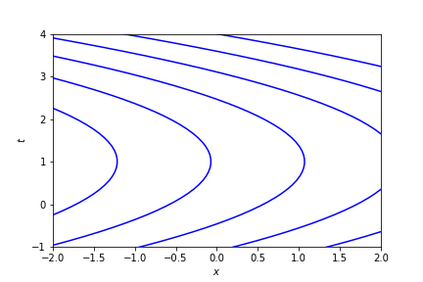  
Solutions:

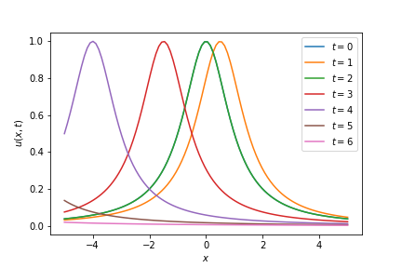

$u\left(x,0\right)=u\left(x,2\right),$ therefore $u\left(x,0\right)$ figure under $u\left(x,2\right)$

1. Use the method of characteristics to solve the initial-boundary value problem:

$$u_{t}+u_{x}=t+x, t>0,x>0$$

$$u\left(x,0\right)=0 \\ u\left(0,t\right)=t$$

Plot the characteristic curves as well as the solution u(x,t) at several different times.

$$\frac{dt}{ds}=1, \frac{dx}{ds}=1, \frac{du}{ds}=t+x$$

$u\left(x,0\right)=0, x>t,=>$ initial: $t=0,x=p,u=0$;

$$t=s, x=s+p \\ \frac{du}{ds}=s+s+p=>u=s^{2}+ps=t^{2}+\left(x-t\right)t=xt$$

$$u=xt$$

$u\left(0,t\right)=0, x<t,=>$ boundary: $t=p,x=0,u=p$;

$$t=s+p, x=s, =>t=x+p$$

$$\frac{du}{ds}=s+p+s=>u=s^{2}+ps+p=x^{2}+\left(t-x\right)x+t-x=tx+t-x$$

$$u=tx+t-x$$

Summing up:

Solution:

$$u=\begin{matrix}xt+t-x, x<t \\ xt, x>t\end{matrix}$$

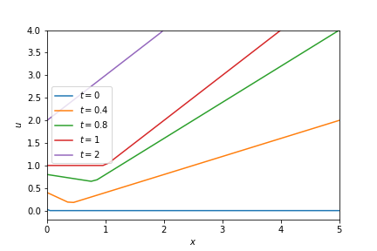

Characteristics:

$$x=t+p, x>t$$

$$t=x+p, x<t$$

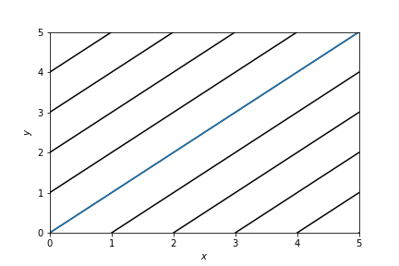

1. Solve the initial value problem for the Hopf equation:

$$u_{t}+uu_{x}=0, x∈R,t>0, u\left(x,0\right)=\begin{matrix}1, 0≤x≤1 \\ 0, otherwise\end{matrix}$$

$$\frac{dt}{ds}=1, \frac{dx}{ds}=u, \frac{du}{ds}=0$$

This equation means that u is speed.

From the initial cond. we have shock at $x=1$, and fan at $x=0$.

Shock speed:

$$\dot{s}=\frac{u_{+}+u_{-}}{2}=\frac{1}{2}+\frac{0}{2}=\frac{1}{2}=>s=\frac{1}{2}t+p$$

Position of shock at time =0 is 1, therefore $s=\frac{1}{2}t+1$

The fan function: $u=\frac{x}{t},$ it intersects shock when: $u=1$ =>

For fan: $x=t$

For shock: $x=\frac{1}{2}t+1$ ( - right side).

Solution is $x=2,t=2$

After this shock speed is $\dot{s}=\frac{u_{+}+u_{-}}{2}=\frac{\frac{s}{t}+0}{2}=\frac{s}{2t}=>\ln\left(s\right)=\ln\left(c\sqrt{t}\right)=>s=c\sqrt{t}$

But when $t=2 then s=2,$ => $s=\sqrt{2t}$

Summing up: $u\left(x,t\right)=0$ 
: if $x≤0$– before fan, $(x>\sqrt{2t},t>2$) and $(x<1+\frac{t}{2},t>2)$- after shock.

$u\left(x,t\right)=1:$ only on the start: $(t<x<1+\frac{t}{2},t<2)$

$u\left(x,t\right)=\frac{x}{t}$-otherwise

Let’s Plot:

$$t=0$$

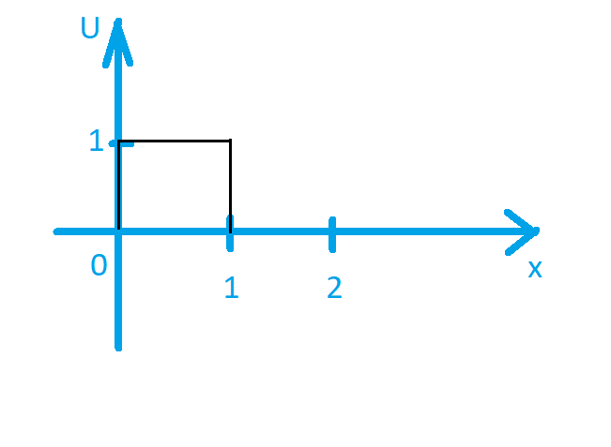

$$t<2$$

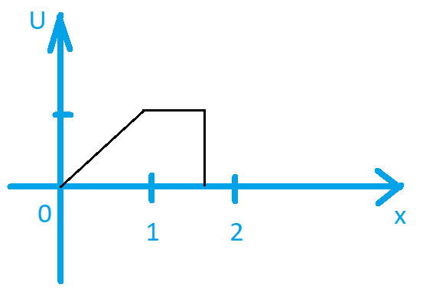

$$t=2$$

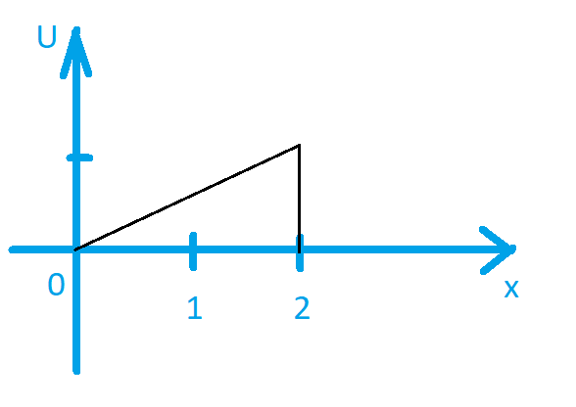

$$t>2$$

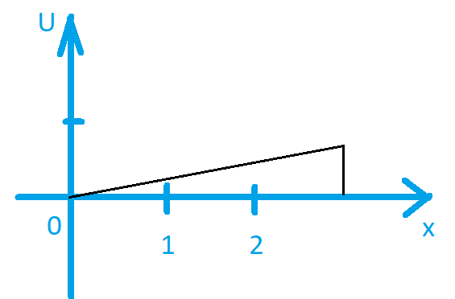

1. Determine the traveling wave solutions $u = U (z), z = x -ct$, of the problem

$${\left(u+\frac{u^{2}}{2}\right)}_{t}=u_{xx}-u_{x}$$

with $U \left(-∞\right)= 0, U \left(∞\right)= 1, U \left(0\right)=\frac{1}{2}$.

Let’s $u=U\left(z\right)$ $$\frac{d\left(U+\frac{U^{2}}{2}\right)}{dt}=\frac{d\left(U+\frac{U^{2}}{2}\right)}{dz}\frac{dz}{dt}=-c\frac{d}{dz}\left(U+\frac{U^{2}}{2}\right) \\ \frac{dx}{dz}=1=>u_{xx}-u_{x}=U_{zz}-U_{z}$$

$$-c\frac{d}{dz}\left(U+\frac{U^{2}}{2}\right)=U_{zz}-U_{z}$$

$$-c\left(U+\frac{U^{2}}{2}\right)=U_{z}-U+C$$

as far as $U^{'}\left(±∞\right)=0$ then:

since $U \left(-∞\right)= 0=> -c\left(0\right)=0-0+C=>C=0$

since $U \left(∞\right)= 1=> -c\left(1+\frac{1}{2}\right)=0-1=>c=\frac{2}{3}$

$$-\frac{2}{3}\left(U+\frac{U^{2}}{2}\right)=U_{z}-U$$

$$U_{z}=-\frac{2}{3}\left(U+\frac{U^{2}}{2}\right)+U=\frac{1}{3}U\left(1-U\right)$$

$$\frac{dU}{U\left(1-U\right)}=\frac{1}{3}dz$$

$$\int{\frac{dU}{U\left(1-U\right)}}=\int{\frac{1}{U}+\frac{1}{1-U}dU}=\ln\left(U\right)-\ln\left(1-U\right)=\ln\left(\frac{U}{1-U}\right)$$

$$\ln\left(\frac{U}{1-U}\right)+\ln\left(A\right)=\frac{1}{3}z \\ \frac{U}{1-U}A=\exp\left(\frac{1}{3}z\right)$$

Since $U \left(0\right)=\frac{1}{2}$ then:

$$\frac{1/2}{1-1/2}A=\exp\left(0\right)=>A=1$$

$$\frac{U}{1-U}=\exp\left(\frac{1}{3}z\right)$$

Finally:

$$U=\frac{\exp\left(\frac{1}{3}z\right)}{1+\exp\left(\frac{1}{3}z\right)}$$

Where $z =x-ct, c=\frac{2}{3}$

1. Consider the reaction-diffusion system

$$u_{t} = Du_{xx} + u + v, 0 < x < π$$

$$v_{t} = 3u - v,$$

with no-flux boundary conditions.

1. Analyze first the spatially homogeneous case with D = 0.

$$u_{t} = u + v, 0 < x < π$$

$$v_{t} = 3u - v,$$

$$J=\left[\begin{matrix}1 & 1 \\ 3 & -1\end{matrix}\right]$$

Fixed point: (0,0) $$τ=0,∆=-4=>sadle point$$

Nullclines: $\left(u=-v\right),(v=3u)$

1. Determine the growth rate σ of the normal modes, $w = {\left[u, v\right]}^{T} = a (t) cos nx, n = 0, 1, 2, ...$

Lecture formula: $\det\left(J-σI-n^{2}A\right)$, where $J=\left[\begin{matrix}1 & 1 \\ 3 & -1\end{matrix}\right]$, $A=\left[\begin{matrix}D & 0 \\ 0 & 0\end{matrix}\right]$

$$\det\left(J-σI-n^{2}A\right)=det\left[\begin{matrix}1-σ-n^{2}D & 1 \\ 3 & -1-σ\end{matrix}\right]=\left(1-σ-n^{2}D\right)\left(-1-σ\right)-3=σ^{2}+σn^{2}D+n^{2}D-4=0$$

Find roots:

$$σ_{1,2}=\frac{-n^{2}D±\sqrt{n^{4}D^{2}-4n^{2}D+16}}{2}$$

1. For a given D, which modes are unstable? Discuss the behavior at large D and at small D.

Unstable modes if $Re\left(σ\right)>0.$

Consider: $n^{4}D^{2}-4n^{2}D+16$ which is always > 0 => $-n^{2}D-\sqrt{n^{4}D^{2}-4n^{2}D+16}<0$

$$Re\left(σ_{2}\right)<0$$

$$-n^{2}D+\sqrt{n^{4}D^{2}-4n^{2}D+16}<0 if n>\frac{2}{\sqrt{D}}$$

Modes unstable if $n<\frac{2}{\sqrt{D}}$ and $Re\left(σ_{1}\right)>0$.

For large D all modes are stable(except $n=0$), because $n<\frac{2}{\sqrt{D}}≪1$

For small D number of unstable modes more, because $\frac{2}{\sqrt{D}}≫1$

1. What is the largest value of D such that spatially non-uniform perturbations grow with time?

$\frac{2}{\sqrt{D}}=1 if D=4=>$ spatially non-uniform perturbations grow with time if $D <4$

1. Plot the neutral curve, i.e. D (n) dependence for zero growth rate, Re(σ) = 0, and

indicate the regions in the D − n plane where the solution is stable and where it is

unstable

As we found before $σ^{2}+σn^{2}D+n^{2}D-4=0$

$$Re\left(σ\right)=0=>σ=0=>n^{2}D-4=0$$

Let’s plot $$D=\frac{4}{n^{2}}$$

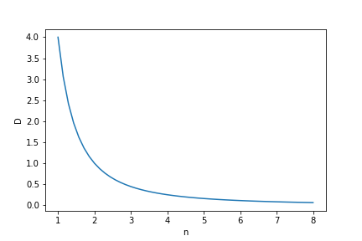

Under line zone of instability

Above line zone of stability.

1. (Extra credit). Equation $u_{t} + c \left(x, t\right)u_{x} = 0$ describes variable-speed advection in a

certain non-uniform medium. Explain how to solve it by the method of characteristics

for general $c (x, t)$ and initial data $u (x, 0) = f (x).$ Next, specialize to $c = 1 + ϵ sin x$

with small parameter $ϵ → 0$ and find an explicit form of the solution including terms

up to $O (ϵ)$. Let $f = e^{-x^{2}}$ and plot the solution at $ϵ = 0.1$ at several different $t$ or as a

surface in the $(x, t)$-plane. What happens if $c = 1 + sin x$?

$$u_{t} + c \left(x, t\right)u_{x} = 0$$

$$\frac{dt}{ds}=1,\frac{dx}{ds}=c \left(x, t\right),\frac{du}{ds}=0$$

$u (x, 0) = f (x)$ =>initial: $t=0,x=p,u=f(p)$

$$\frac{dt}{ds}=1=>t=s$$

$\frac{dx}{ds}=c \left(x, s\right)=>$ solve this with respect to $x$, and we get $x=w\left(s\right)-w\left(0\right)+p$

$$p=x- w\left(s\right)+w\left(0\right)$$

$$\frac{du}{ds}=0=>u=const\left(s\right)=f\left(p\right)$$

$$u=f\left(x- w\left(t\right)+w\left(0\right)\right), where w\left(s\right) is the solution of \frac{dx}{ds}=c \left(x, s\right)$$